**ASSIGNMENT - 2**

**CBIVR**

**PRIYANSHU SHARMA**

**15BCE1282**

**QUESTION - 1**

**Motion Based Multiple Object Tracking**

**Theory**

Detection of moving objects and motion-based tracking are important components of many computer vision applications, including activity recognition, traffic monitoring, and automotive safety. The problem of motion-based object tracking can be divided into two parts:

1. Detecting moving objects in each frame

2. Associating the defections corresponding to the same object over time

The detection of moving objects uses a background subtraction algorithm based on Gaussian mixture models. Morphological operations are applied to the resulting foreground mask to eliminate noise. Finally, blob analysis detects groups of connected pixels, which are likely to correspond to moving objects.

The association of detections to the same object is based solely on motion. The motion of each track is estimated by a Kalman filter. The filter is used to predict the track's location in each frame, and determine the likelihood of each detection being assigned to each track.

Track maintenance becomes an important aspect of this example. In any given frame, some detections may be assigned to tracks, while other detections and tracks may remain unassigned. The assigned tracks are updated using the corresponding detections. The unassigned tracks are marked invisible. An unassigned detection begins a new track.

Each track keeps count of the number of consecutive frames, where it remained unassigned. If the count exceeds a specified threshold, the example assumes that the object left the field of view and it deletes the track.

**CODE**

function MotionBasedMultiObjectTrackingExample()

obj = setupSystemObjects();

tracks = initializeTracks();

nextId = 1;

while ~isDone(obj.reader)

frame = readFrame();

[centroids, bboxes, mask] = detectObjects(frame);

predictNewLocationsOfTracks();

[assignments, unassignedTracks, unassignedDetections] = ...

detectionToTrackAssignment();

updateAssignedTracks();

updateUnassignedTracks();

deleteLostTracks();

createNewTracks();

displayTrackingResults();

end

function obj = setupSystemObjects()

% Initialize Video I/O

% Create objects for reading a video from a file, drawing the tracked

% objects in each frame, and playing the video.

% Create a video file reader.

obj.reader = vision.VideoFileReader('atrium.mp4');

% Create two video players, one to display the video,

% and one to display the foreground mask.

obj.maskPlayer = vision.VideoPlayer('Position', [740, 400, 700, 400]);

obj.videoPlayer = vision.VideoPlayer('Position', [20, 400, 700, 400]);

% Create System objects for foreground detection and blob analysis

% The foreground detector is used to segment moving objects from

% the background. It outputs a binary mask, where the pixel value

% of 1 corresponds to the foreground and the value of 0 corresponds

% to the background.

obj.detector = vision.ForegroundDetector('NumGaussians', 3, ...

'NumTrainingFrames', 40, 'MinimumBackgroundRatio', 0.7);

% Connected groups of foreground pixels are likely to correspond to moving

% objects. The blob analysis System object is used to find such groups

% (called 'blobs' or 'connected components'), and compute their

% characteristics, such as area, centroid, and the bounding box.

obj.blobAnalyser = vision.BlobAnalysis('BoundingBoxOutputPort', true, ...

'AreaOutputPort', true, 'CentroidOutputPort', true, ...

'MinimumBlobArea', 400);

end

function tracks = initializeTracks()

% create an empty array of tracks

tracks = struct(...

'id', {}, ...

'bbox', {}, ...

'kalmanFilter', {}, ...

'age', {}, ...

'totalVisibleCount', {}, ...

'consecutiveInvisibleCount', {});

end

function frame = readFrame()

frame = obj.reader.step();

end

function [centroids, bboxes, mask] = detectObjects(frame)

% Detect foreground.

mask = obj.detector.step(frame);

% Apply morphological operations to remove noise and fill in holes.

mask = imopen(mask, strel('rectangle', [3,3]));

mask = imclose(mask, strel('rectangle', [15, 15]));

mask = imfill(mask, 'holes');

% Perform blob analysis to find connected components.

[~, centroids, bboxes] = obj.blobAnalyser.step(mask);

end

function predictNewLocationsOfTracks()

for i = 1:length(tracks)

bbox = tracks(i).bbox;

% Predict the current location of the track.

predictedCentroid = predict(tracks(i).kalmanFilter);

% Shift the bounding box so that its center is at

% the predicted location.

predictedCentroid = int32(predictedCentroid) - bbox(3:4) / 2;

tracks(i).bbox = [predictedCentroid, bbox(3:4)];

end

end

function [assignments, unassignedTracks, unassignedDetections] = ...

detectionToTrackAssignment()

nTracks = length(tracks);

nDetections = size(centroids, 1);

% Compute the cost of assigning each detection to each track.

cost = zeros(nTracks, nDetections);

for i = 1:nTracks

cost(i, :) = distance(tracks(i).kalmanFilter, centroids);

end

% Solve the assignment problem.

costOfNonAssignment = 20;

[assignments, unassignedTracks, unassignedDetections] = ...

assignDetectionsToTracks(cost, costOfNonAssignment);

end

function updateAssignedTracks()

numAssignedTracks = size(assignments, 1);

for i = 1:numAssignedTracks

trackIdx = assignments(i, 1);

detectionIdx = assignments(i, 2);

centroid = centroids(detectionIdx, :);

bbox = bboxes(detectionIdx, :);

% Correct the estimate of the object's location

% using the new detection.

correct(tracks(trackIdx).kalmanFilter, centroid);

% Replace predicted bounding box with detected

% bounding box.

tracks(trackIdx).bbox = bbox;

% Update track's age.

tracks(trackIdx).age = tracks(trackIdx).age + 1;

% Update visibility.

tracks(trackIdx).totalVisibleCount = ...

tracks(trackIdx).totalVisibleCount + 1;

tracks(trackIdx).consecutiveInvisibleCount = 0;

end

end

function updateUnassignedTracks()

for i = 1:length(unassignedTracks)

ind = unassignedTracks(i);

tracks(ind).age = tracks(ind).age + 1;

tracks(ind).consecutiveInvisibleCount = ...

tracks(ind).consecutiveInvisibleCount + 1;

end

end

function deleteLostTracks()

if isempty(tracks)

return;

end

invisibleForTooLong = 20;

ageThreshold = 8;

% Compute the fraction of the track's age for which it was visible.

ages = [tracks(:).age];

totalVisibleCounts = [tracks(:).totalVisibleCount];

visibility = totalVisibleCounts ./ ages;

% Find the indices of 'lost' tracks.

lostInds = (ages < ageThreshold & visibility < 0.6) | ...

[tracks(:).consecutiveInvisibleCount] >= invisibleForTooLong;

% Delete lost tracks.

tracks = tracks(~lostInds);

end

function createNewTracks()

centroids = centroids(unassignedDetections, :);

bboxes = bboxes(unassignedDetections, :);

for i = 1:size(centroids, 1)

centroid = centroids(i,:);

bbox = bboxes(i, :);

% Create a Kalman filter object.

kalmanFilter = configureKalmanFilter('ConstantVelocity', ...

centroid, [200, 50], [100, 25], 100);

% Create a new track.

newTrack = struct(...

'id', nextId, ...

'bbox', bbox, ...

'kalmanFilter', kalmanFilter, ...

'age', 1, ...

'totalVisibleCount', 1, ...

'consecutiveInvisibleCount', 0);

% Add it to the array of tracks.

tracks(end + 1) = newTrack;

% Increment the next id.

nextId = nextId + 1;

end

end

function displayTrackingResults()

% Convert the frame and the mask to uint8 RGB.

frame = im2uint8(frame);

mask = uint8(repmat(mask, [1, 1, 3])) .* 255;

minVisibleCount = 8;

if ~isempty(tracks)

% Noisy detections tend to result in short-lived tracks.

% Only display tracks that have been visible for more than

% a minimum number of frames.

reliableTrackInds = ...

[tracks(:).totalVisibleCount] > minVisibleCount;

reliableTracks = tracks(reliableTrackInds);

% Display the objects. If an object has not been detected

% in this frame, display its predicted bounding box.

if ~isempty(reliableTracks)

% Get bounding boxes.

bboxes = cat(1, reliableTracks.bbox);

% Get ids.

ids = int32([reliableTracks(:).id]);

% Create labels for objects indicating the ones for

% which we display the predicted rather than the actual

% location.

labels = cellstr(int2str(ids'));

predictedTrackInds = ...

[reliableTracks(:).consecutiveInvisibleCount] > 0;

isPredicted = cell(size(labels));

isPredicted(predictedTrackInds) = {' predicted'};

labels = strcat(labels, isPredicted);

% Draw the objects on the frame.

frame = insertObjectAnnotation(frame, 'rectangle', ...

bboxes, labels);

% Draw the objects on the mask.

mask = insertObjectAnnotation(mask, 'rectangle', ...

bboxes, labels);

end

end

% Display the mask and the frame.

obj.maskPlayer.step(mask);

obj.videoPlayer.step(frame);

end

end

**OUTPUT**

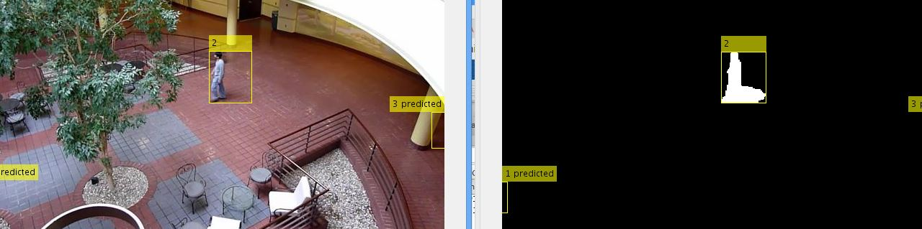

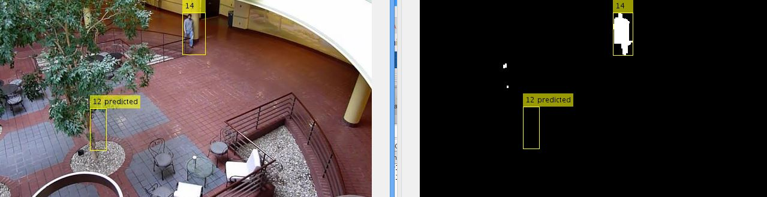

**QUESTION - 2**

**Object Tracking and Motion Estimation**

**Theory**

**Motion estimation** is the process of determining [motion vectors](https://en.wikipedia.org/wiki/Motion_vector" \o "Motion vector) that describe the transformation from one 2D image to another; usually from adjacent [frames](https://en.wikipedia.org/wiki/Video_frame" \o "Video frame) in a video sequence. It is an [ill-posed problem](https://en.wikipedia.org/wiki/Well-posed_problem" \o "Well-posed problem) as the motion is in three dimensions but the images are a projection of the 3D scene onto a 2D plane. The motion vectors may relate to the whole image (global motion estimation) or specific parts, such as rectangular blocks, arbitrary shaped patches or even per [pixel](https://en.wikipedia.org/wiki/Pixel" \o "Pixel). The motion vectors may be represented by a translational model or many other models that can approximate the motion of a real video camera, such as rotation and translation in all three dimensions and zoom.

**CODE**

videoFileReader = vision.VideoFileReader('visionface.avi');

videoPlayer = vision.VideoPlayer('Position',[100,100,680,520]);

objectFrame = step(videoFileReader);

objectRegion = [264,122,93,93];

objectImage = insertShape(objectFrame,'Rectangle',objectRegion,'Color','red');

figure;

imshow(objectImage);

title('Red box shows object region');

points = detectMinEigenFeatures(rgb2gray(objectFrame),'ROI',objectRegion);

pointImage = insertMarker(objectFrame,points.Location,'+','Color','white');

figure;

imshow(pointImage);

title('Detected interest points');

tracker = vision.PointTracker('MaxBidirectionalError',1);

initialize(tracker,points.Location,objectFrame);

while ~isDone(videoFileReader)

frame = step(videoFileReader);

[points, validity] = step(tracker,frame);

out = insertMarker(frame,points(validity, :),'+');

step(videoPlayer,out);

end

release(videoPlayer);

release(videoFileReader);

**OUTPUT**

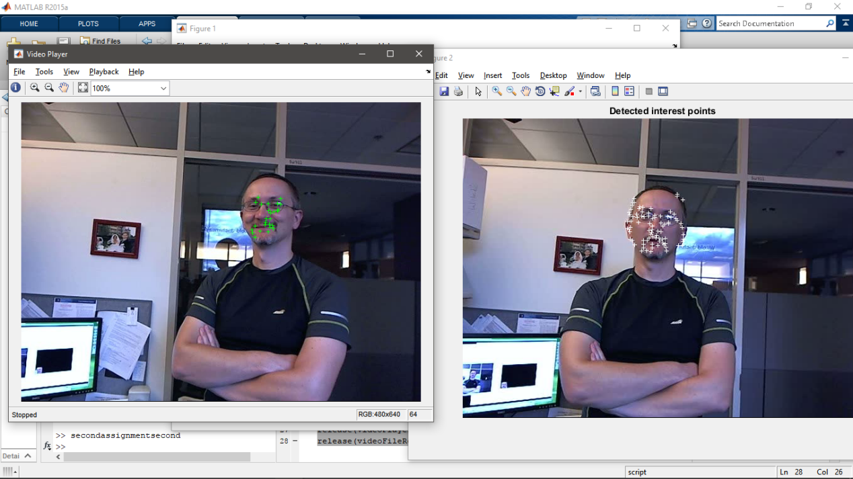

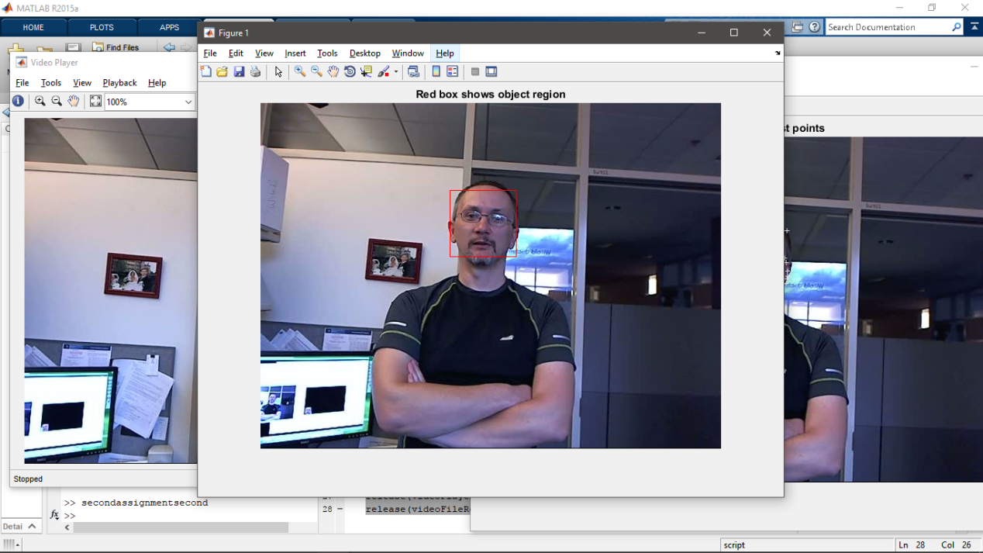

**QUESTION - 3**

**Retrieval Image command**

**Theory**

It will search set for similar images

**CODE**

dataDir = fullfile(toolboxdir('vision'),'visiondata','bookCovers');

bookCovers = imageDatastore(dataDir);

thumbnailGallery = [];

for i = 1:length(bookCovers.Files)

I = readimage(bookCovers,i);

thumbnail = imresize(I,[300 300]);

thumbnailGallery = cat(4,thumbnailGallery,thumbnail);

end

figure

montage(thumbnailGallery);

imageIndex = indexImages(bookCovers);

queryDir = fullfile(dataDir,'queries',filesep);

queryImage = imread([queryDir 'query3.jpg']);

imageIDs = retrieveImages(queryImage,imageIndex);

bestMatch = imageIDs(1);

bestImage = imread(imageIndex.ImageLocation{bestMatch});

figure

imshowpair(queryImage,bestImage,'montage')

**OUTPUT**

